Smart public restroom

Ganesh college of engineering

In salem

Submitted by,

Y.Esther (leader)

k.Anusha

T.Gopika

G.Subasri

Contents

|  |  |
| --- | --- |
| S.NO | CONTENTS |
| 1. | INTRODUCTION |
| 2. | ABSTRACT |
| 3. | SCOPE OF THE PROJECT |
| 4. | WORKING PRINCIPLE |
| 5 | DESCRIPTION OF ARCHITECTURE |
| 6. | WORKING MODEL AND ADVANTAGES |
| 7. | CONCLUSION |

SMART PUBLIC RESTROOM

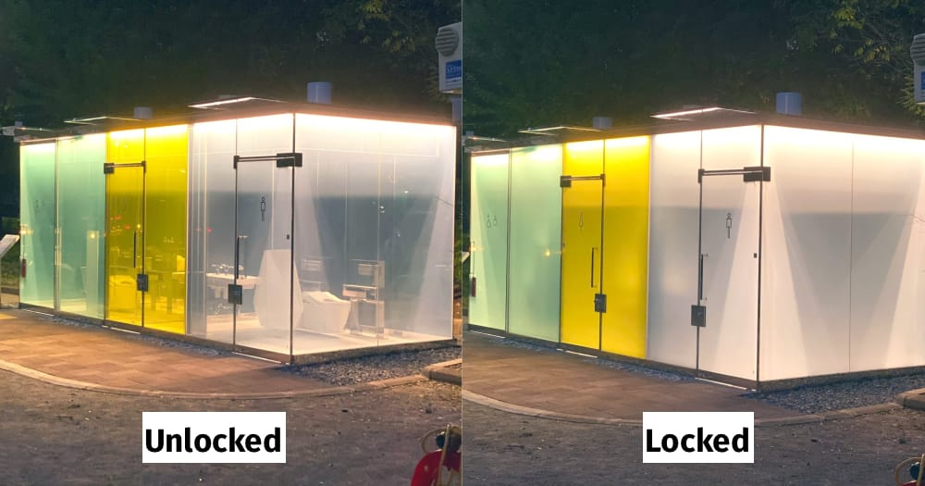

ABSTRACT

In the cutting edge world , The advance are definitely grown, yet at the Same time the cleanliness in our nation is under risk .The abstract of this paper is to deliver clean and hygiene toilets .Our development is to use safe and hygienic toilets .This paper is based on IOT and image –processing concepts using different sensors like smell sensors ,IR sensors ,sonic sensors, RFID reader. By using this sensors , we can create the smart public restroom .

INTRODUCTION:

In our country , people do not have enough knowledge of using toilets. This leads to several diseases, such as Malaria , Hepatitis , Flu, Cholera ,Streptococcus ,Typhoid , etc. Hence we introduce the concept in the IOT called “**swechh Shithouse”** The term swachh means ‘Clean’ .Then

The term shithouse means ‘ Toilet ’ .it is introduce to use and maintain the toilets in the clean and hygienic way.

SCOPE OF THE PROJECT

In this paper we are going to provide the clean toilets. This paper can create the awareness among the people about the clean and hygienic toilets. Finally ,this concept is the one of the stepping stone to the “clean and disease free India”.

WORKING PRINCIPLE

* In the first phase is used to discover the dirt present in the toilet.
* Here the set of sample images are given as input .
* After using the Toilets , the sensors senses the basin of the toilets .
* Then it relates the sensed image with the input image.
* If the dirt present , it increase the alarm .
* Then the user wants to be clean the waste.
* In the second phase, Figaro sensor is used to perceive the unwanted gases present in the toilet.
* In the Figaro sensor , a particular range is to be stable earlier manner .

ARCHITECTURE OF THE PROPOSED SYSTEM

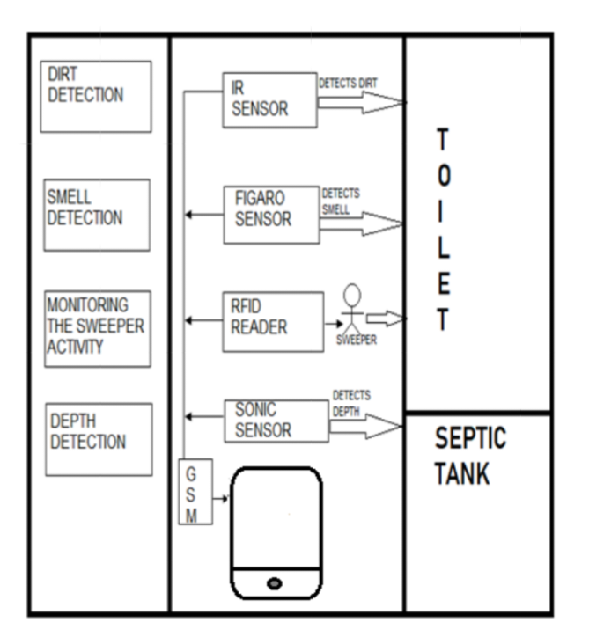

DESCRITION OF ARCHITECTURE

HARDWARE REQUIREMENTS:

* Microcontroller
* Power supply
* LCD display
* Buzzer
* Infrared sensor
* Sonic sensor
* Gas sensor
* RFID
* GSM modem

SOFTWARE REQUIRENENTS

* Embedded C

MICROCONTROLLER

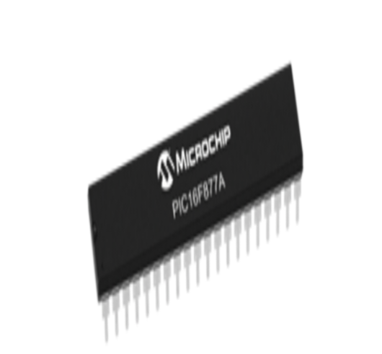

Microcontrollers are designed for embedded applications , in contrast to the microprocessors used in personal computers or other general-purpose applications.

INFRARED SENSOR

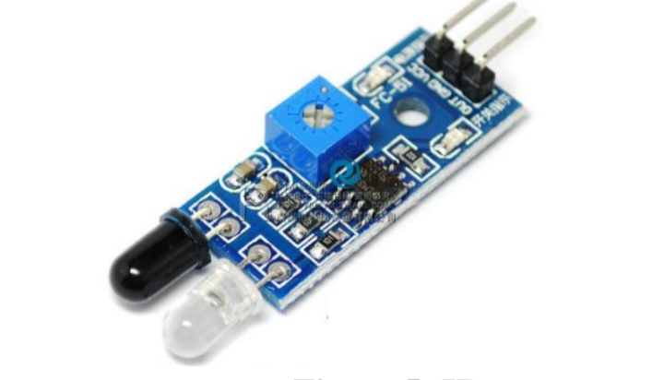

If it can detect the dirt, it raises the alarm, and users may get embraced and they clean it. This system can create the responsiveness among the people.

IR sensor is used to detect the dirt present in the toilet.

SMELL SENSOR

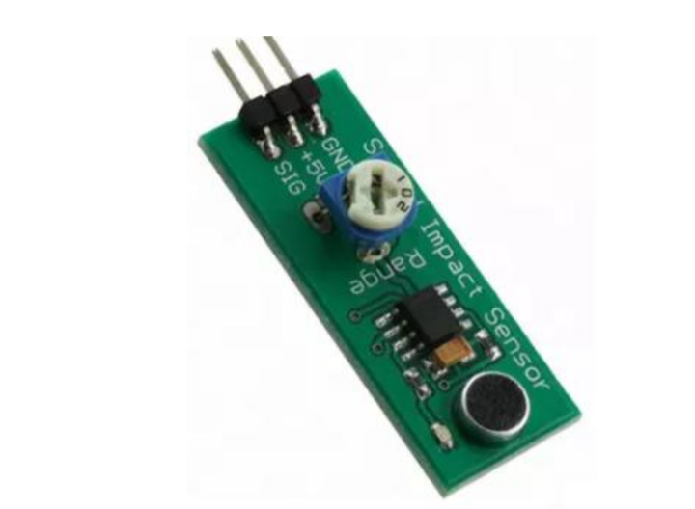

The smell sensor is used to detect the unwanted smell and gases in the toilet .For this purpose, we are going to use the sensor called Figaro sensor.

After sensing the unwanted gases, it can blink the red light. Then the sweeper can clean it by using particular Cleaning Agents.

RFID READER 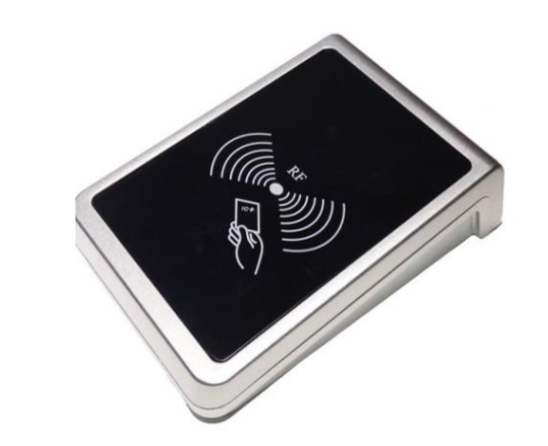

RFID stands for Radio Frequency Identification. It can be used for monitoring the sweeper.

The sweeper desires to show the tag before the cleaning process is going to start and after it is finished.

WORKING MODEL

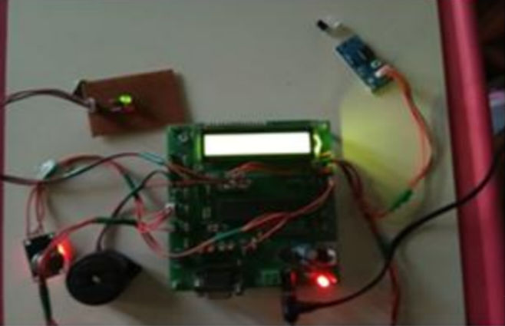

This is module of the proposed system. Here the sensors are connected with the microcontroller.

**DIRT DETECTION:**

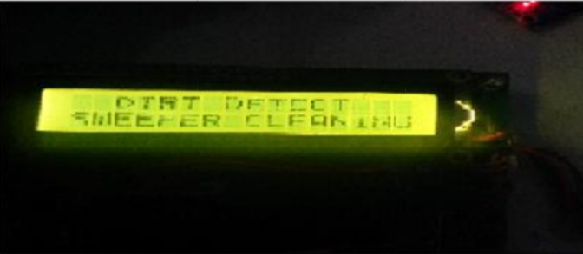

It shows the dirt detection in the toilets.

* When your robot finds more dirt than usual concentrated in one area , it will active dirt detect and work harder to clean the same area until the sensors detect fewer particles in that particular area.

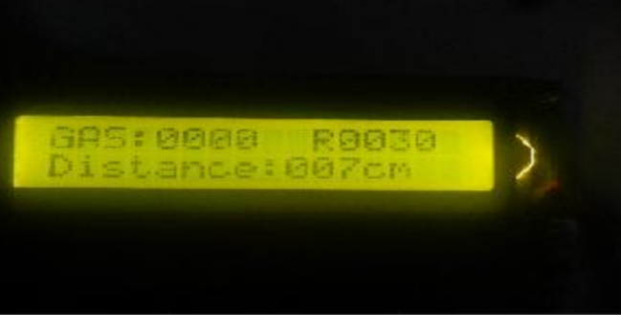

**SMELL DETECTION**

* It shows the smell detection and depth detection.
* If the sensors detect a high levels of NH3 (in ppm),we should clean our toilet based on that indication.

**ADVANTAGES:**

* It can creates an awareness among the people about the proper toilet management.
* It can prevents the many contagious diseases like malaria, typhoid, cholera, streptococcus, asthma, etc..
* It can promotes the “Swachhbharat” scheme.

**CONCLUSION:**

Our proposed project will create awareness among the people about the roper sanitation. It makes use of internet of things, which is a rapidly growing technology. We can maintain the cleanliness which is next to the godliness .keep clean , Be safe